Dear Candidate,

Thank you for applying to one of our frontend engineering positions. Before the technical assessment we would ask you to try and solve the small development exercise that is listed below. During the interview we will walk through the code together.

The scenario will take about 30-60 mins to complete. If you get stuck on some aspects of the scenario or run out of time, it’s no big deal and we can discuss it during the interview. If you have any questions on the scenario itself, please reach out to us.

Please send us your solution up-front if possible.

Good luck with the scenario!

# Scenario

Write an SPA that contains a search field, and a list of five elements underneath. It should look roughly like this:

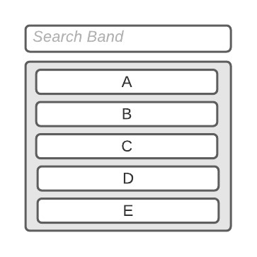

Per default the list should show A, B, C, D, E.

Every second the elements should rotate by one position:

|  |  |  |
| --- | --- | --- |
| **List after 1 second** | **after 2 seconds** | **after 3 seconds** |
| B | C | D |
| C | D | E |
| D | E | A |
| E | A | B |
| A | B | C |

When the user types into the search field, query the apple music API like this: [https://itunes.apple.com/search?term=radiohead.](https://itunes.apple.com/search?term=radiohead) The output contains a list with songs. Each song has a property "collectionName" (the album). Sort all albums alphabetically and take the first five. E.g. “A Moon Shaped Pool“, „In Rainbows“, “Kid A”, “OK Computer”, “Pablo Honey”.

The list should keep rotating with a 1 second interval and the new albums should be added from bottom to top:

|  |  |  |  |  |
| --- | --- | --- | --- | --- |
| **1 sec** | **2 sec** | **User types “radiohead”** | **3 sec** | **4 sec** |
| A | B | C | D |
| B | C | D | E |
| C | D | E | A |
| D | E | A | A Moon Shaped Pool |
| E | A | A Moon Shaped Pool | In Rainbows |

Items from previous searches should not appear again, but only the current search term items should be rotated.